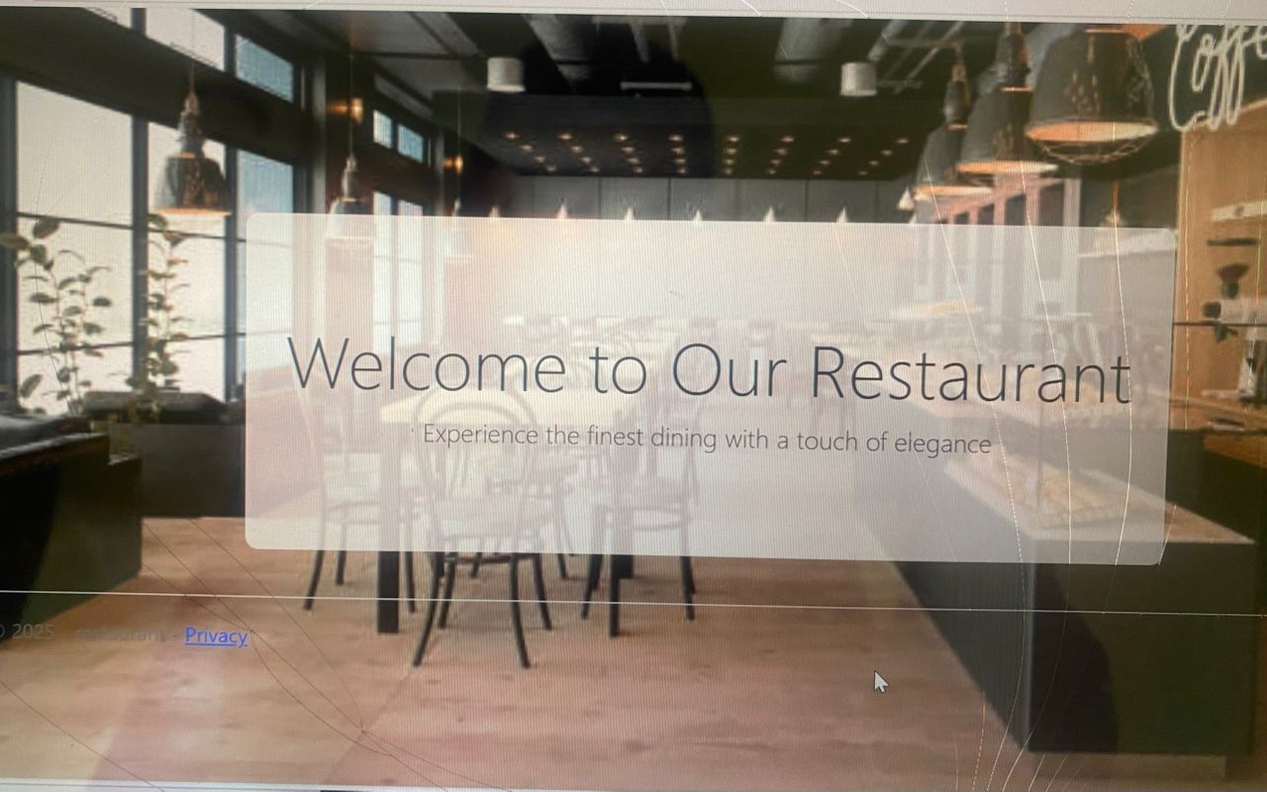Restaurant manager system report

Introduction and System Overview

Introduction

In today's fast-paced restaurant industry, effective management systems are essential for operational efficiency and customer satisfaction. A Restaurant Manager System (RMS) is a comprehensive solution that streamlines various restaurant operations, including reservations, order processing, inventory management, and customer engagement.

Objectives

Improve Efficiency: Automate routine tasks to minimize manual errors and improve service speed.

Enhance Customer Experience\*: Provide a seamless experience from reservation to payment.

Data-Driven Decisions\*: Utilize analytics to inform menu changes, staffing needs, and marketing strategies.

3. System Features

.1 User Management

Role-based access control for managers, staff, and customers.

Profile management for staff efficiency.

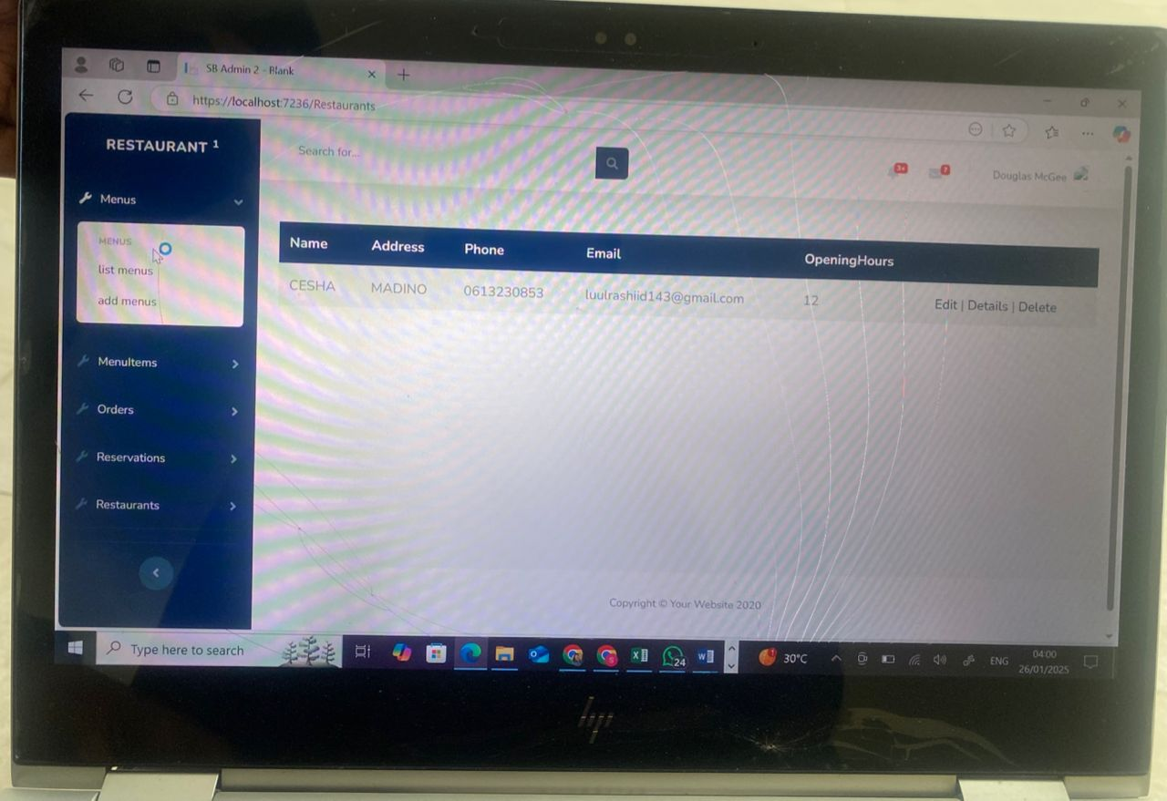2 Reservation System

Online booking options with real-time table availability.

Mobile-friendly interface for customer convenience.

4. Menu Management

Dynamic menu updates with seasonal specials.

Nutritional information and allergen alerts.

Order and Inventory Management

Order Management

Order Taking

Intuitive interface for staff to input orders quickly.

Table management to track orders by table number.

.2 Real-time Order Tracking

Status updates for kitchen staff and servers.

Notifications for completed orders.

6. Inventory Management

6.1 Stock Tracking

Automated tracking of ingredient levels.

Alerts for low stock to prevent shortages.

.2 Supplier Management

Integration with suppliers for easy reordering.

Historical data on supplier performance and pricing

7. Billing and Payments

.1 Invoice Generation

Automatic generation of detailed invoices.

Options for splitting bills among customers.

Payment Processing

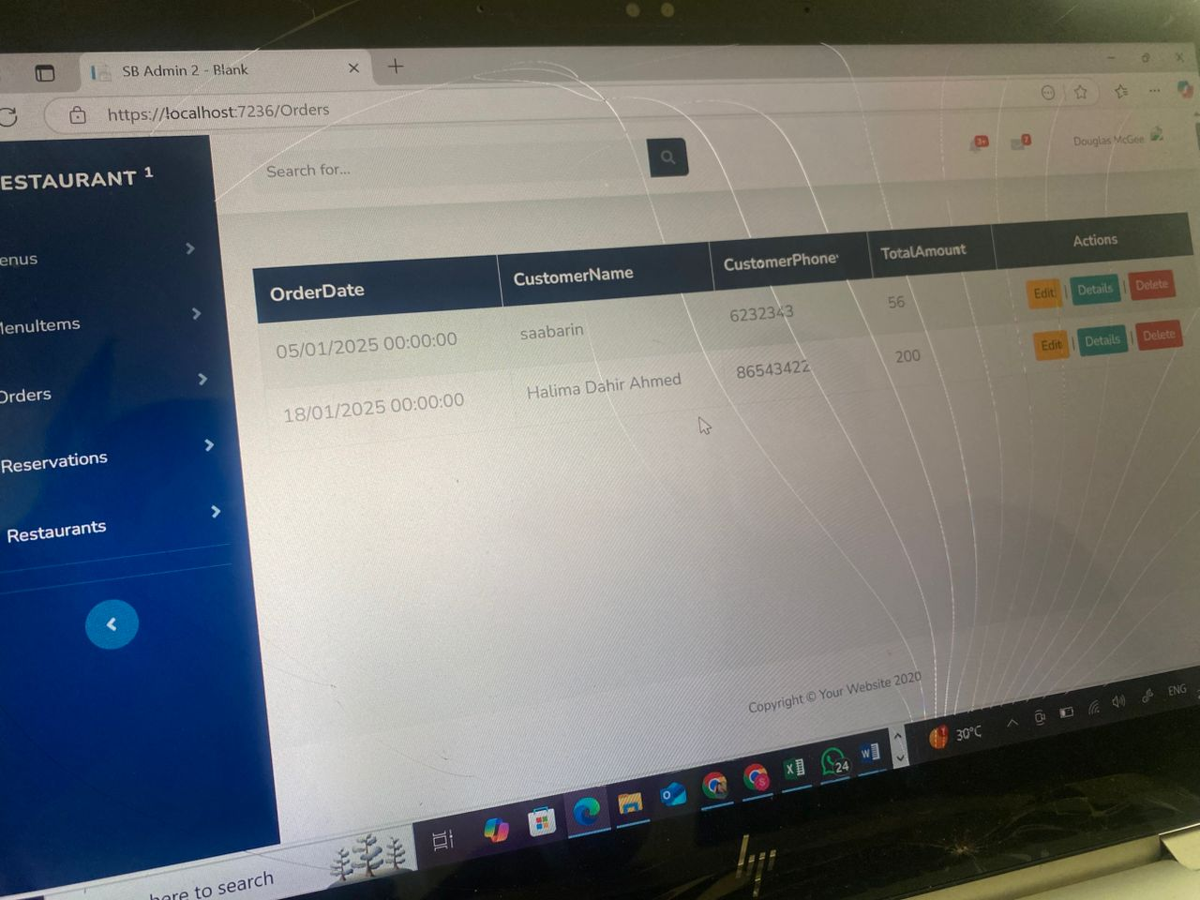 Multiple payment methods (cash, card, mobile payments).

Secure transaction processing.

Reporting and Analytics

8. Reporting and Analytics

.1 Sales Reports

Daily, weekly, and monthly sales summaries.

Performance metrics for individual staff and menu items.

2 Customer Feedback

Tools for collecting and analyzing customer feedback.

Integration with online review platforms.

9. User Interface Design

.1 Dashboard

Overview of key metrics at a glance (sales, reservations, inventory).

- Customizable widgets for user preferences.

2 User Experience

Responsive design for desktop and mobile access.

Simplified navigation to enhance usability.

Implementation, Challenges, and Conclusion

10. Implementation Plan

10.1 Development Phases

Phase 1: Requirements gathering and system design.

Phase 2: Development and internal testing.

Phase 3: User acceptance testing and deployment.

.2 Timeline

- Estimated completion time for each phase.

- Milestones for assessment.

11. Challenges and Solutions

11.1 Potential Challenges

- Resistance to change from staff.

- Data privacy and security concerns.

11.2 Proposed Solutions

- Comprehensive training sessions for staff.

Robust security protocols and compliance with regulations.

12. Conclusion

The Restaurant Manager System is designed to enhance operational efficiency, improve customer satisfaction, and provide valuable insights through data analytics. By adopting this system, restaurants can better navigate the complexities of modern dining while positioning themselves for future growth and success.

Integration with loyalty programs.

Enhanced mobile app features for customer engagement.

Future Enhancements

This report serves as a complete overview of a Restaurant Manager System, detailing its purpose, features, implementation plan, and potential challenges. If you need more specific information or further elaboration on any section, please let me know!